 | Pimpri Chinchwad Municipal Corporation  Jagadguru Sant Tukaram Maharaj Santpith School & Jr. College  Patilnagar, Talgaon Chikhali, Pune - 411062 | 

Sr.No | Name of Teacher |  | Photo
1 | Dr. Dnyaneshwar Gadage | Principal
2 | Snehal Rahul Pagar | Headmistress
3 | Mayuri Suraj Muluk | Coordinator
4 | Sakharam Radhakisan Pitale | PGT | 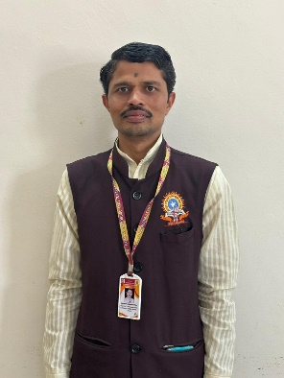
5 | Mugdha Amey Shirodakar | PGT | 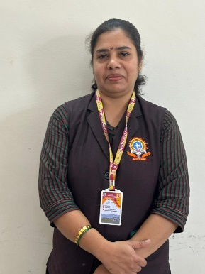
6 | Santosh Ekanath Khote | PGT | 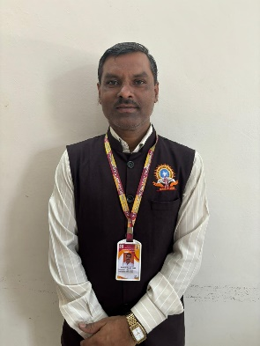
7 | Shobha Santosh Shirke | TGT | 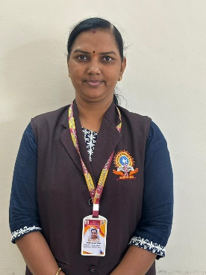
8 | Dhanashri Harshal Patil | TGT | 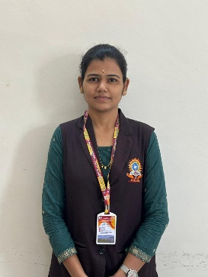
9 | Sucheta Pratik Pujari | TGT | 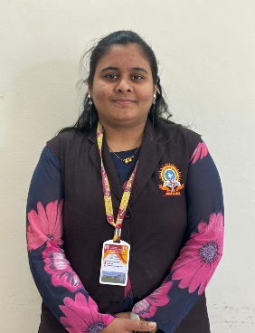
10 | Deepmala Jaiswal | TGT | 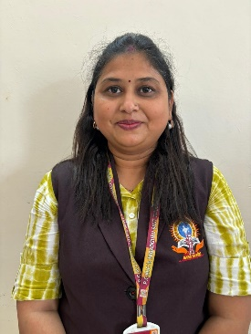
11 | Vaishali Rajendrakumar Nimse | TGT | 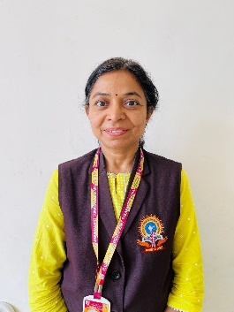
12 | Pavitra Mallikarjun Kalappanavar | TGT | 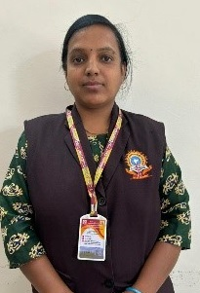
13 | Vishakha Bhatesing Girase | PRT | 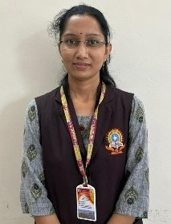
14 | Suvarna Dnyaneshwar Wagh | TGT | 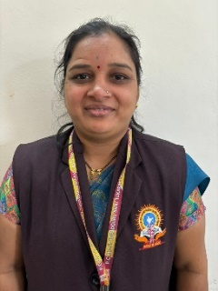
15 | Deepika Sagar Patil | PRT | 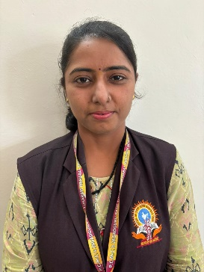
16 | Pranita Prashant Dhawale | PET (PRT) | 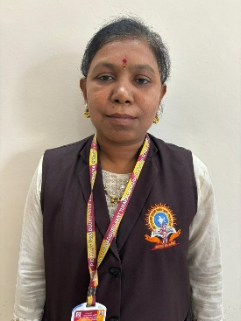
17 | Mangal Pushpraj Ambre | TGT | 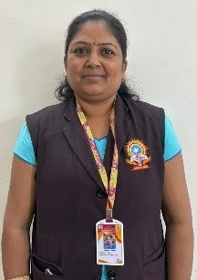
18 | Avinash Dharmaraj Bhogil | PRT | 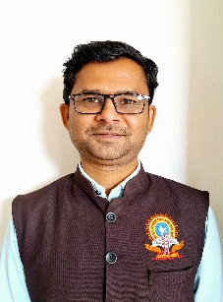
19 | Jyoti Rajesh Lokhande | TGT | 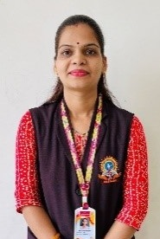
20 | Neha Gyneshwar Nafde | PRT | 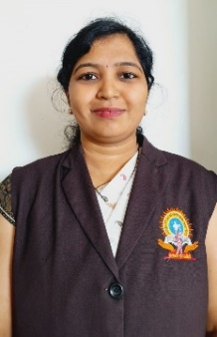
21 | Archana Ashok Desai | TGT | 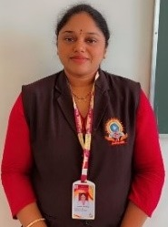
22 | Deepali Dattatray Waghmare | PRT | 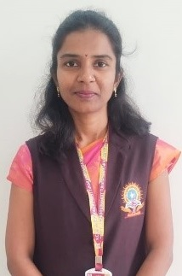
23 | Rachana Ambadas Deshmukh | PRT | 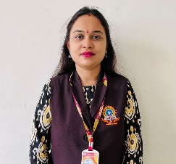
24 | Sapnarani Amol Bangar | PRT | 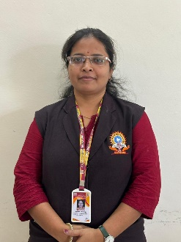
25 | Rajabhau Jayram Phad | TGT | 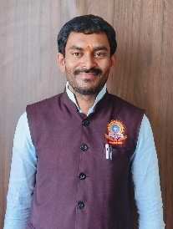
26 | Vivek Narendra Bhalerao | PRT | 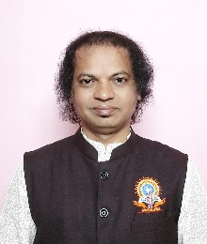
27 | Swati Sahebrao Nikam | PGT | 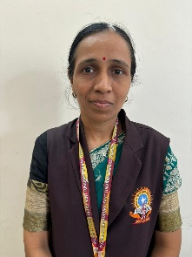
28 | Shwetal Nandkumar Bhosale | TGT | 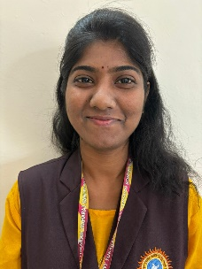
29 | Bhalchandra Banshidhar Rode | PRT | 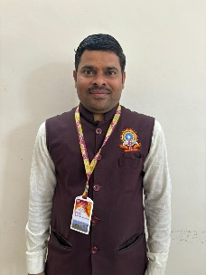
30 | Gayatri Ganesh Bari | PRT | 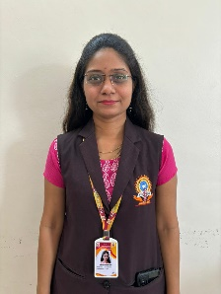
31 | Snehal Jitendra Bambe | PRT | 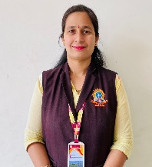
32 | Priyanka Mandar Malkar | PRT | 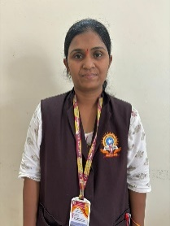
33 | Manisha Gaikwad | PRT | 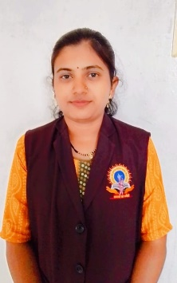
34 | Swati Shailendrakumar Mohite | PRT | 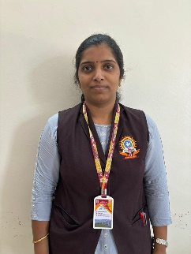
35 | Jayashri Ramkrushna Patil | PRT | 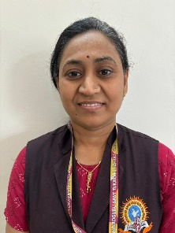
36 | Prajakta Vishal Choure | PRT | 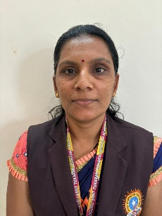
37 | Madhura Sanil Lotankar | PRT | 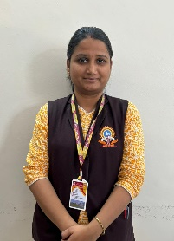
38 | Varsha Sangram Ruikar | PRT | 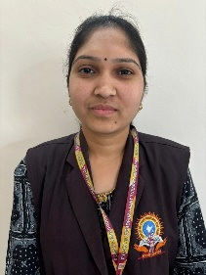
39 | Vishakha Shivling Pawar | TGT | 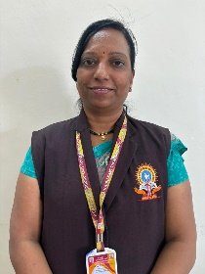
40 | Sachinkumar Bhagwat Shinde | PRT | 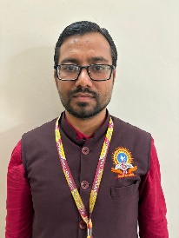
41 | Mrunmayee Mandar Kulkarni | PRT | 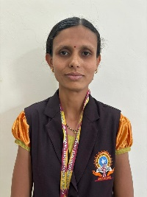
42 | Suvarna Suraj Jamdhade | PRT | 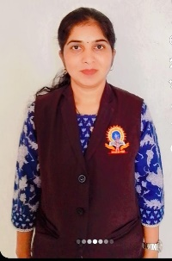
43 | Esha Madhukar Patole | PRT | 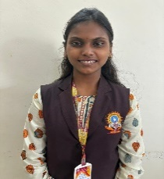
44 | Vijay Bhasme | PET (PRT) | 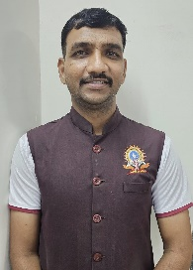
45 | Priyanka Sagar Kondekar | PRT | 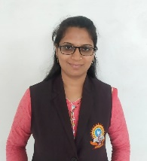
46 | Gorakhnath Dattatray More | PET (PRT) | 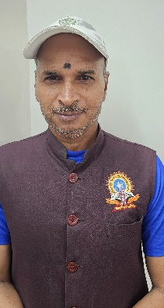
47 | Pooja Sachin Londhe | NTT | 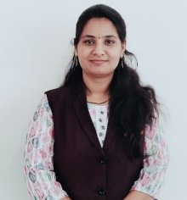
48 | Savita Vikram Godase | NTT | 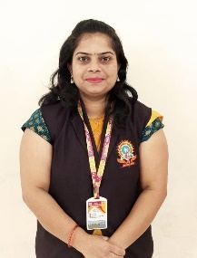
49 | Suman Navnath Kolekar | NTT | 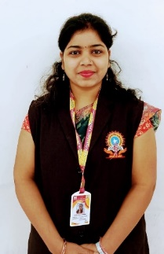
50 | Suvarna Arun Bhongale | NTT | 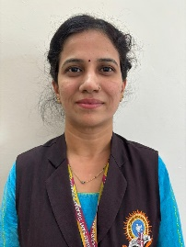
51 | Priyanka Ganesh Ghorpade | NTT | 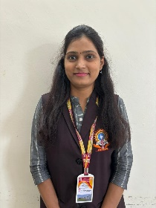
52 | Jayashri Nilesh Bahirat | NTT | 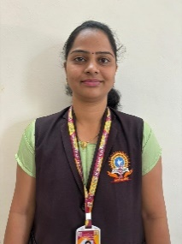
53 | Sarika Sudhir Badkhal | NTT | 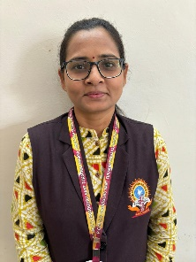
54 | Pournima Lalit Ingle | NTT | 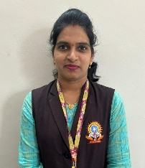
55 | Shraddha Madhav Kumbhar | NTT | 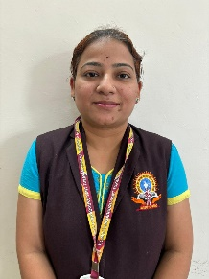
56 | Supriya Shital Patil | NTT | 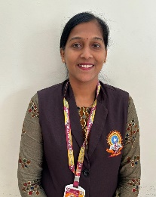
57 | Bharati Tushar Bhadane | NTT | 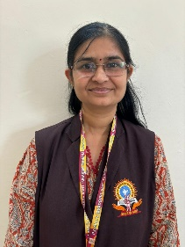
58 | Pallavi Rupesh Malkapure | NTT | 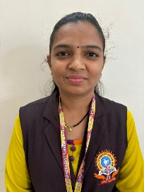
59 | Shraddha Nachare | NTT | 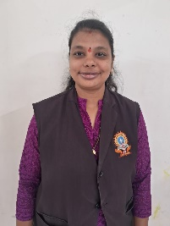
60 | Mohini Rajendra Kusekar | NTT | 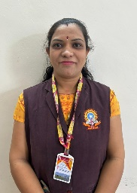
61 | Shital Shailesh Amodkar | NTT | 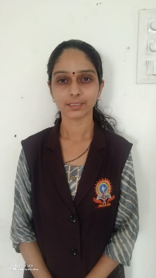
62 | Padmaja Amit Patil | NTT | 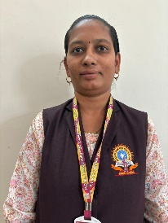
63 | Rajani Vijay Chaudhari | NTT | 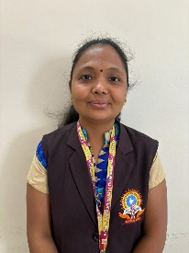
64 | Vaishali Rangnath Dhayarkar | NTT | 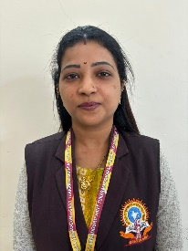
65 | Mohini Ashish Lokhande | NTT | 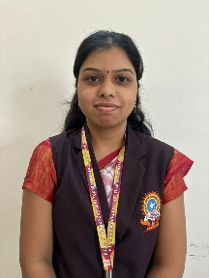
66 | Suvarna Ganesh Hundare | Librarian | 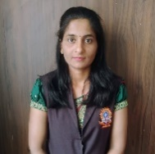
67 | Anirudha Pandurang More | Lab Technician | 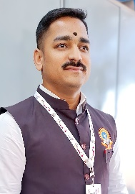
68 | Suraj Shankar Waghmare | Administrator | 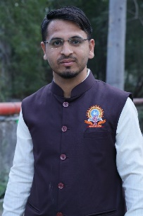
69 | Prerana Kedar Bhairat | Accountant | 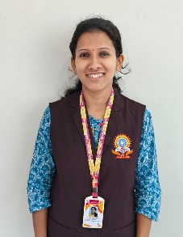
70 | Rachana Vishal Nagarkar | Clerk | 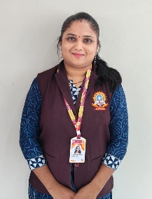
71 | Deepak Yashwant Bende | Typist | 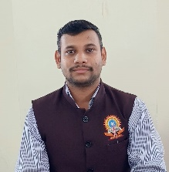
72 | Prajakta Arote | Special Educator | 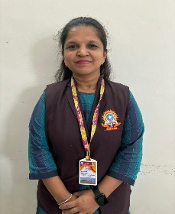
73 | Parnika Kulkarni | Counselor

